**Lab 04 - Building Spring Boot RESTful Web Services and Spring Data JPA**

# 1. Introduction

Imagine you're a new fresher Spring Boot developer of IT department in a University. Your manager has asked you to develop a RESTful API for Orchid Management to manage just a simple information of an orchid.

Orchid (OrchidID, OrchidName, isNatural, orchidDescription, orchidCategory, isAttractive, orchidURL)

The RESTful API has to support adding, viewing, modifying, and removing information for an orchid - a standardized usage action verbs better known as Create, Read, Update, Delete (CRUD).

This lab explores creating a RESTful API using **Spring Boot** 3 with Data Source is MS SQL Server. An **SQL Server** **Database** will be created to persist the orchid data (reading and managing) by **Spring Data JPA**

# 2. Lab Objectives

In this lab, you will:

* Use the **Intellij** **IDEA** to create Spring Initializr Project (Maybe you can create the Spring Initializr project in <https://start.spring.io/> then open this project in IntelliJ IDEA.
* Choose **Spring Web** for Building web, including *RESTful*, applications using Spring MVC. Uses Apache Tomcat as the default embedded container. **Spring Data JPA SQL for** persisting data in SQL stores with Java Persistence API using Spring Data and Hibernate. **MS SQL Server Driver SQL -** A JDBC and R2DBC driver that provides access to Microsoft SQL Server and Azure SQL Database from any Java application.
* Use in SQL Server Database as a Data Source
* Develop 3-Layer with Repository Architecture to perform CRUD actions using RESTful API with Spring Boot 3.
* Run the project and test the application actions.

# Activity 01: Design the Orchid Management

**Step 01**. Open IntelliJ IDEA, File | New | Initializr Project

In the left pane of the New Project wizard, select Spring Initializr Project.

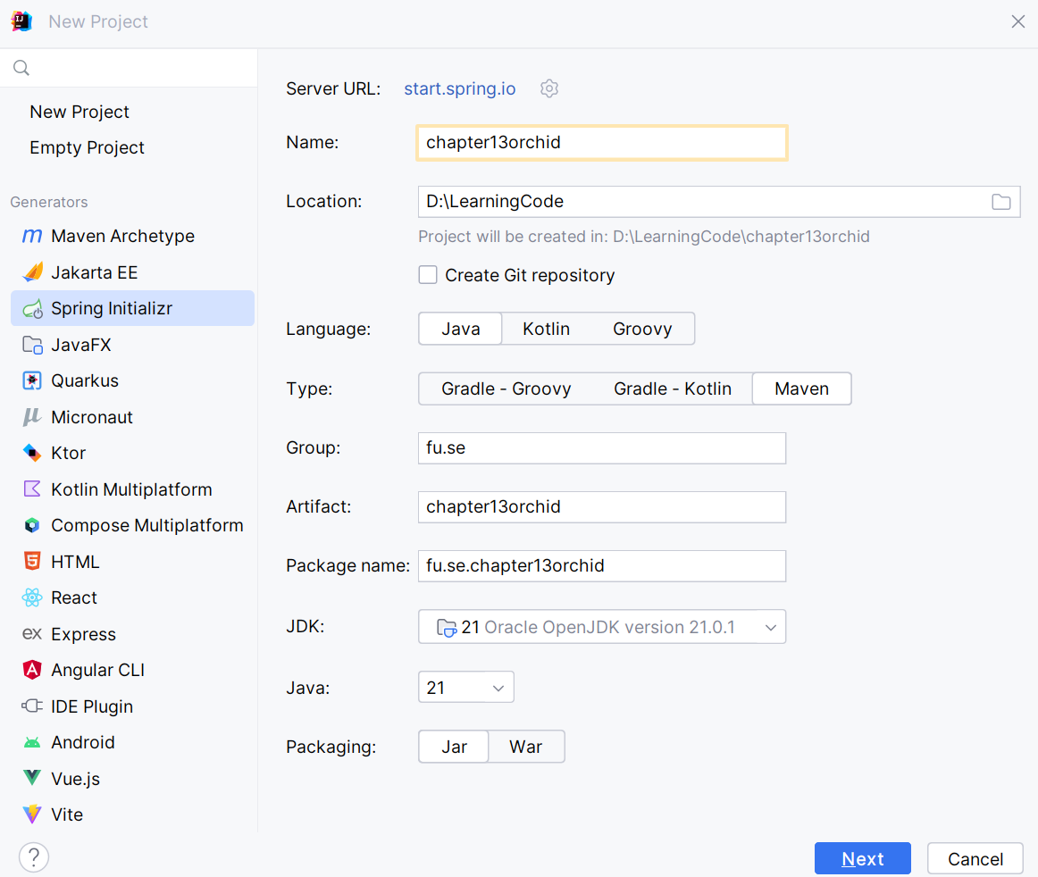

**Step 02.** Fill the information → Next

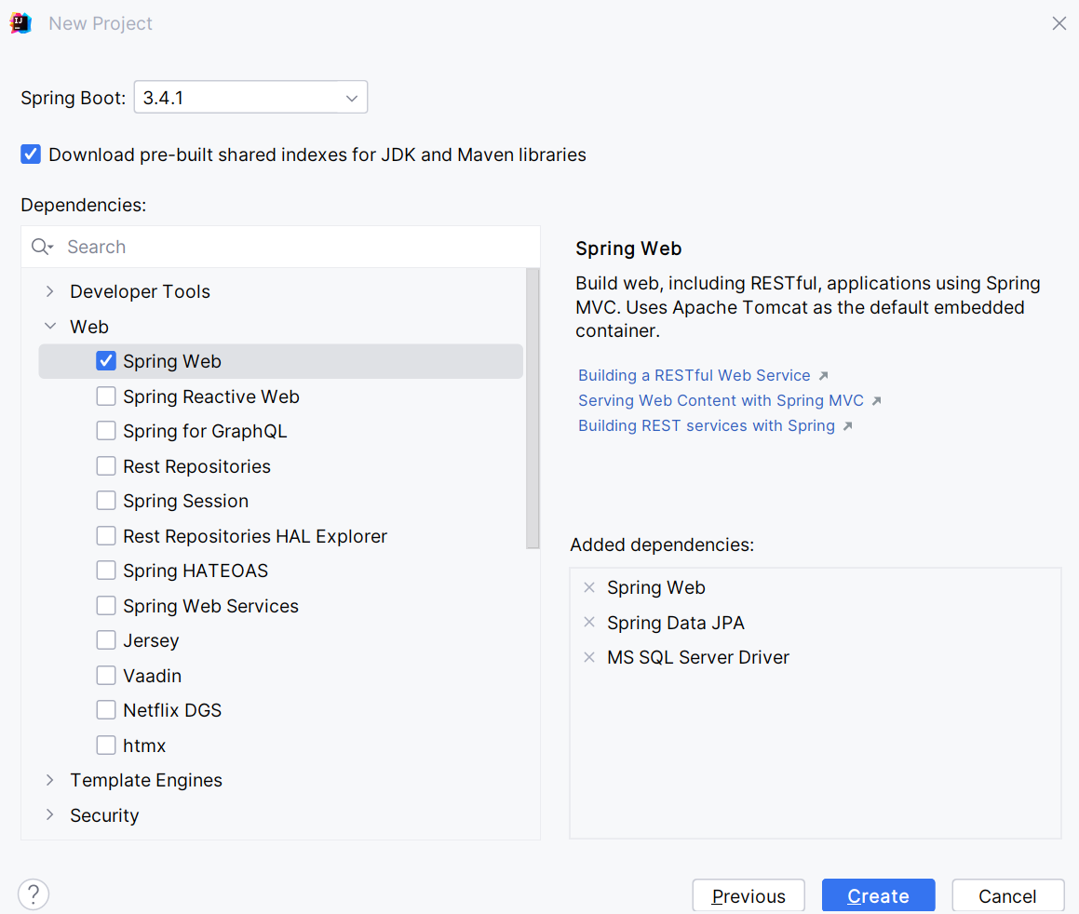

**Step 03**. Choose the dependency/dependencies → Click Create

Or you can using Spring Initializr project in <https://start.spring.io/> then open this project in IntelliJ IDEA

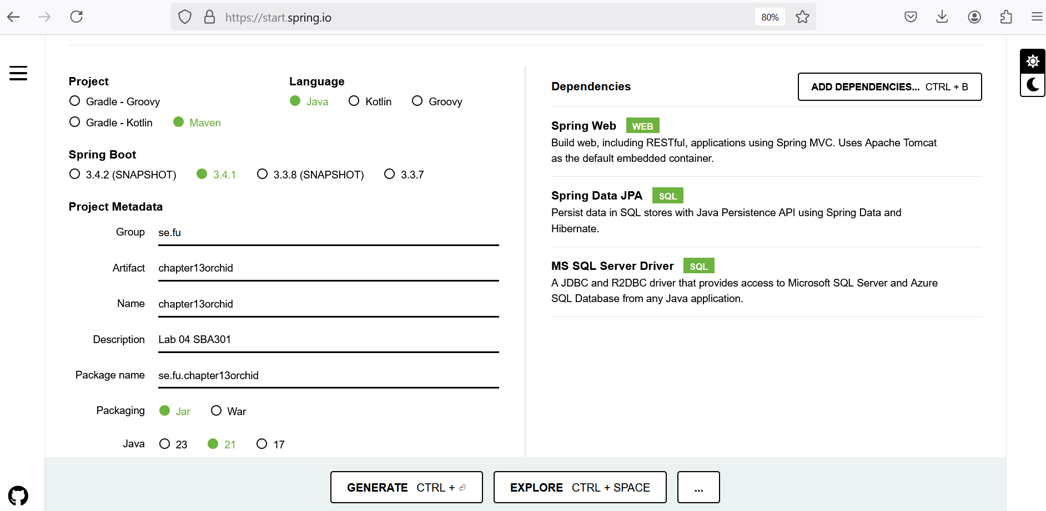

**Step 04**. Edit pom.xml, add the dependencies for

* MS SQL Server Driver **mssql-jdbc**
* Spring Web - RESTful API: **spring-boot-starter-web**
* Spring Data JPA for Paging and Sort data: **spring-data-jpa**
* Testing **spring-boot-starter-test**

<dependencies>  
 <dependency>  
 <groupId>org.springframework.boot</groupId>  
 <artifactId>**spring-boot-starter-data-jpa**</artifactId>  
 </dependency>  
 <dependency>  
 <groupId>org.springframework.boot</groupId>  
 <artifactId>**spring-boot-starter-web**</artifactId>  
 </dependency>  
 <dependency>  
 <groupId>com.microsoft.sqlserver</groupId>  
 <artifactId>**mssql-jdbc**</artifactId>  
 <scope>runtime</scope>  
 </dependency>  
 <dependency>  
 <groupId>org.springframework.boot</groupId>  
 <artifactId>**spring-boot-starter-test**</artifactId>  
 <scope>test</scope>  
 </dependency>  
</dependencies>

**Step 05**. The structure of the Lab project

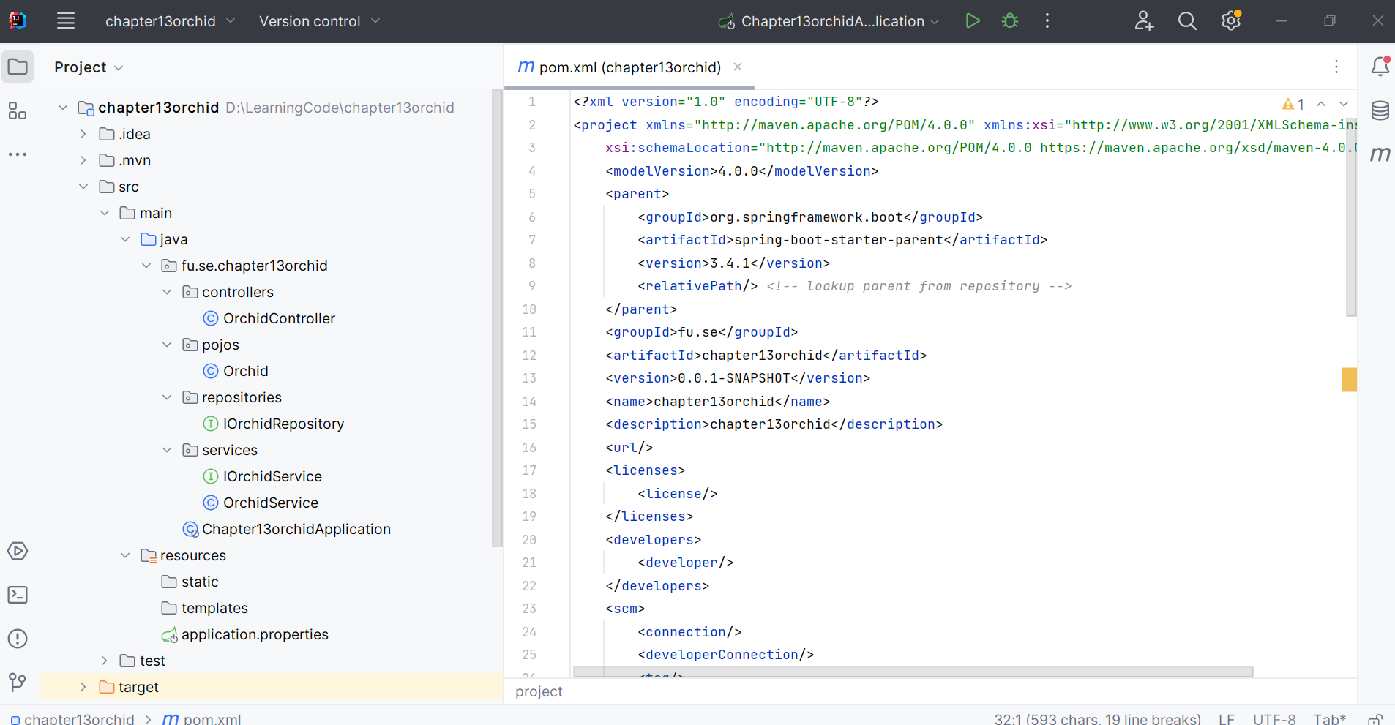

**Step 06**. The application.properties file

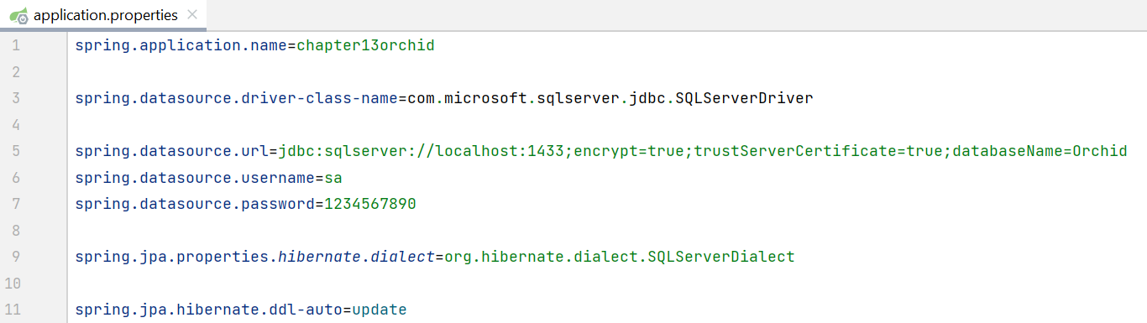

# Activity 02: Implement RESTful API Orchid Management with CRUD functions

**Step 01**. Create **pojos** package, then create Orchid Entity

Entity Class: Represents a database table

Annotations:

* @Entity: Marks the class as a JPA entity
* @Id: Specifies the primary key field
* @GeneratedValue: Strategy for generating primary key values
* @Column: Maps a field to a database column

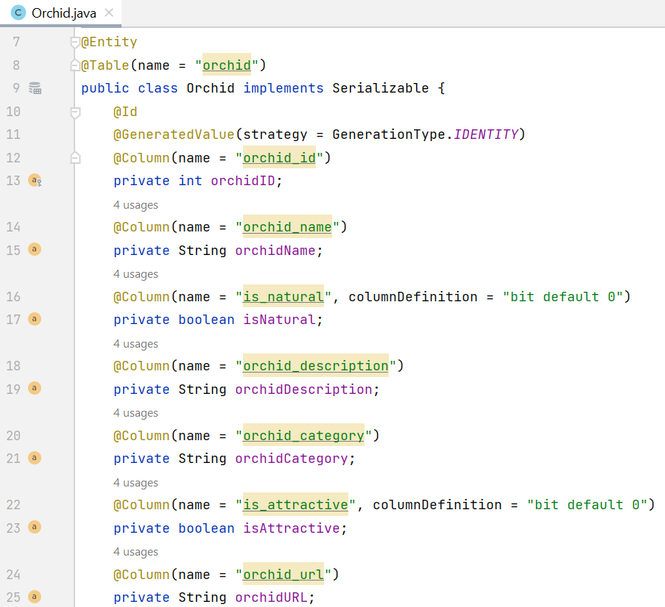

**Step 02**. Implement Repository by creating **repositories** package, IOrchidRepository interface

* Create JPA repository interface, this interface extending JpaRepository
* Provides CRUD operations and more
* No implementation needed (Spring Data JPA provides it)

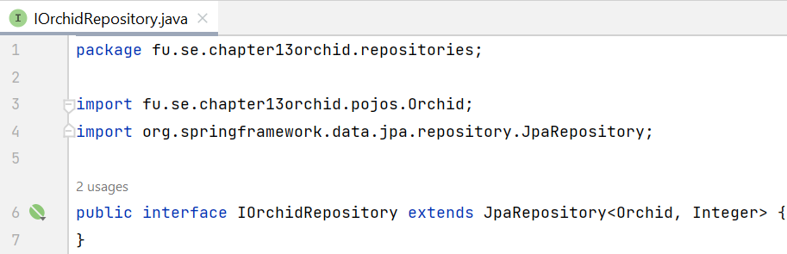

**Step 03**. Implement Service Layer includes: IOrchidService interface, OrchidService class in **services** package.

* Define service interfaces: Create interfaces to define the business logic for application.
* Implement service classes: Implement the service interfaces and use the repositories to interact with the database.
* Use the IOrchidRepository to interact with the Repository (Data Layer)

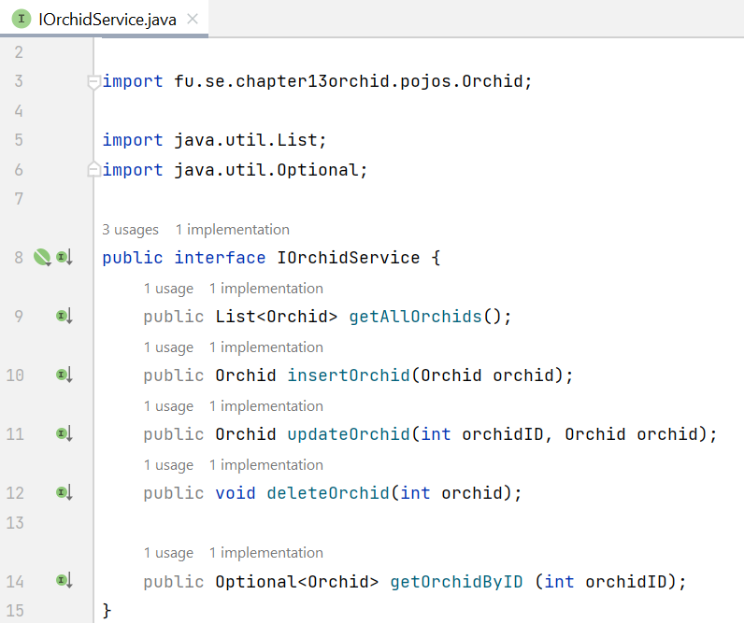

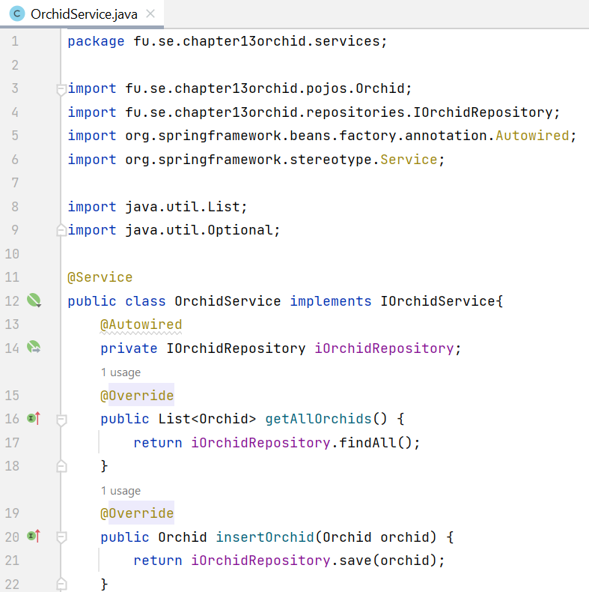

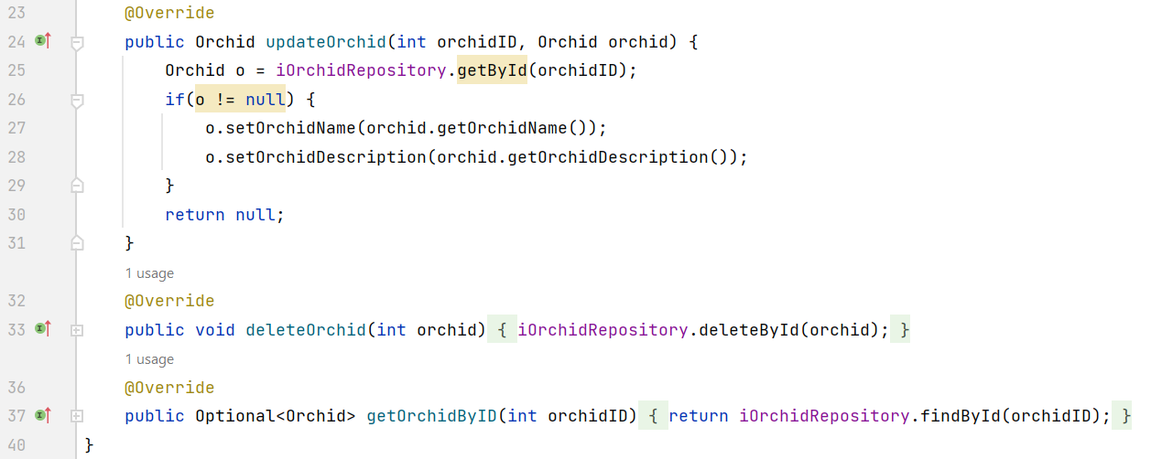

**Step 04**. Implement REST Controller

@RequestMapping - Maps HTTP requests to specific controller methods based on the request path, HTTP method, and other criteria. It can be used at both the class and method level. Attributes of @RequestMapping:

* value: Specifies the request path.
* method: Specifies the HTTP method (e.g., RequestMethod.GET, RequestMethod.POST).
* params: Specifies request parameters that must be present.
* headers: Specifies request headers that must be present.
* consumes: Specifies the content type of the request body.
* produces: Specifies the content type of the response body.

The annotations are shortcuts for @RequestMapping with specific HTTP methods. They simplify the code and improve readability.

* @GetMapping
* @PostMapping
* @PutMapping
* @DeleteMapping
* @PatchMapping

@PathVariable: Extracts values from URI path variables and binds them to method parameters.

@RequestParam - Extracts values from query parameters and binds them to method parameters.

@RequestParam attributes:

* value: Specifies the name of the query parameter.
* required: Indicates whether the parameter is required.
* defaultValue: Specifies a default value if the parameter is not present.

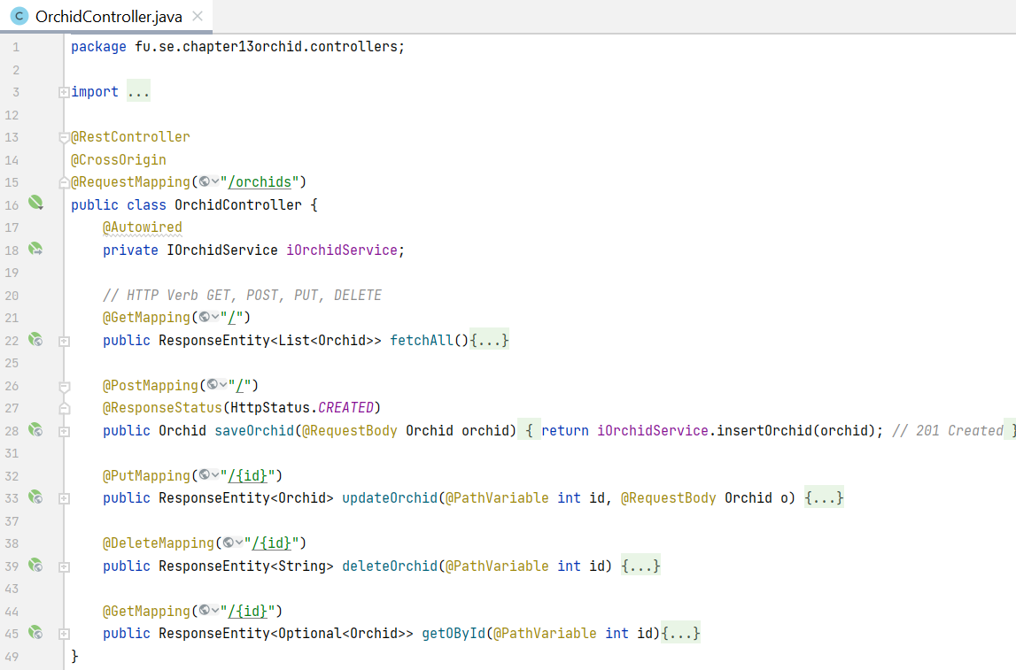

The details of action methods in REST Controller

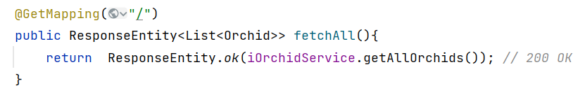

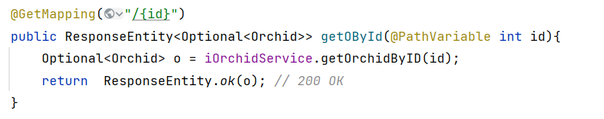

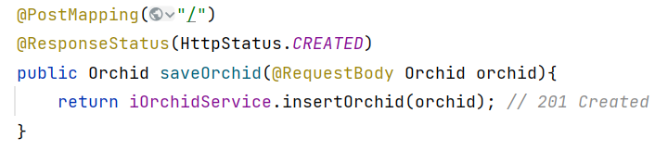

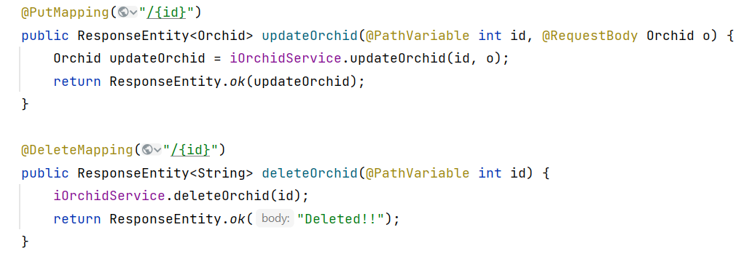



**Step 05**. The main entry point for Spring Boot application

The @SpringBootApplication annotation is a convenience annotation in Spring Boot that combines several annotations to simplify the configuration and initialization of a Spring Boot application.

When you use @SpringBootApplication, it automatically includes the following annotations:

* **@EnableAutoConfiguration:** This annotation tells Spring Boot to automatically configure your application based on the libraries on the classpath. For example, if Spring Boot detects that you have a database driver in your project, it will automatically configure a datasource.
* **@ComponentScan**: This tells Spring to scan the current package and its sub-packages for annotated components (such as @Component, @Service, @Repository, and @Controller) to register them as Spring beans.
* **@Configuration**: This marks the class as a source of bean definitions for the application context, meaning that you can define @Bean methods in this class.

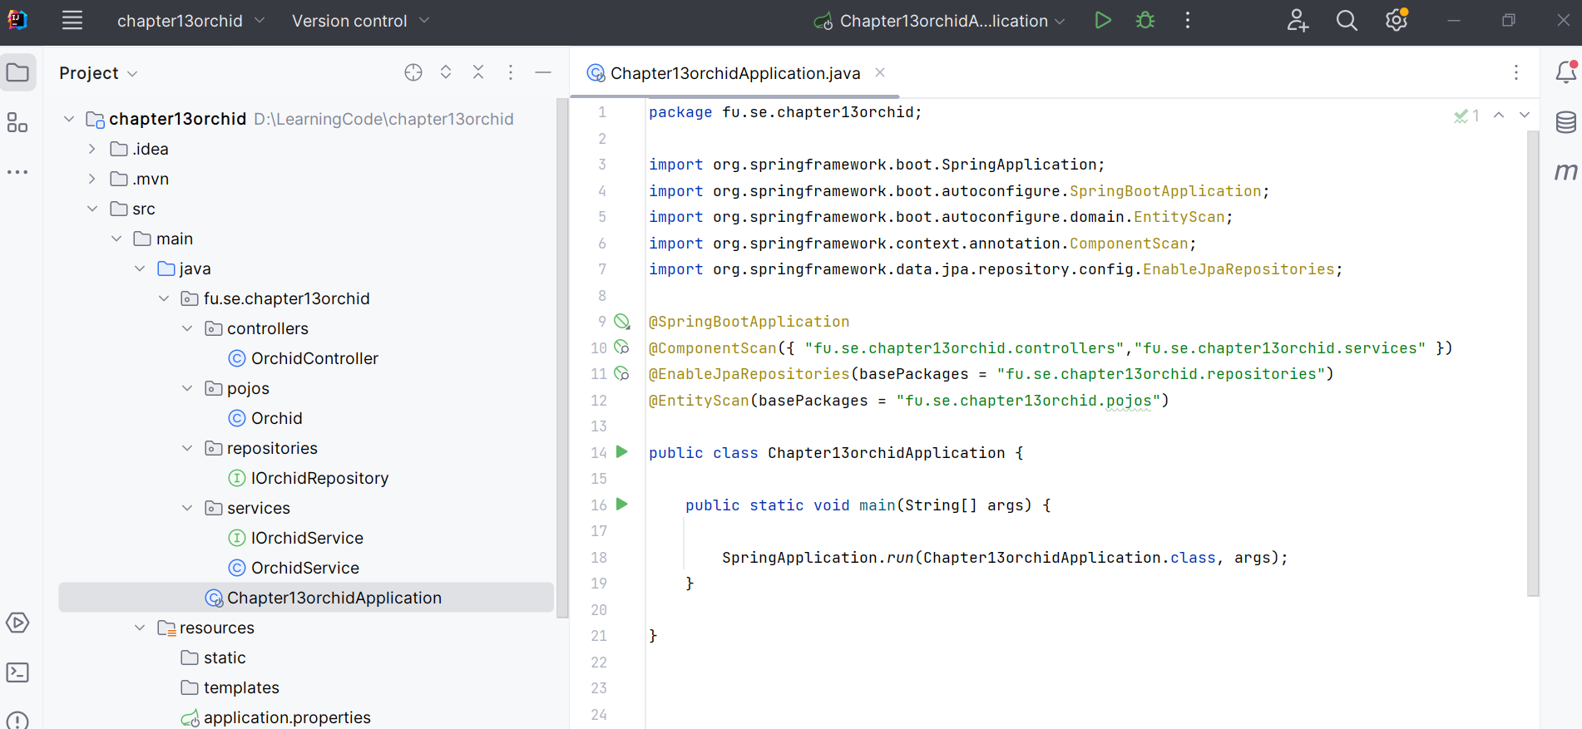

# Activity 03: Run and test the RESTful API

**Step 01.** Run the RESTful API Project

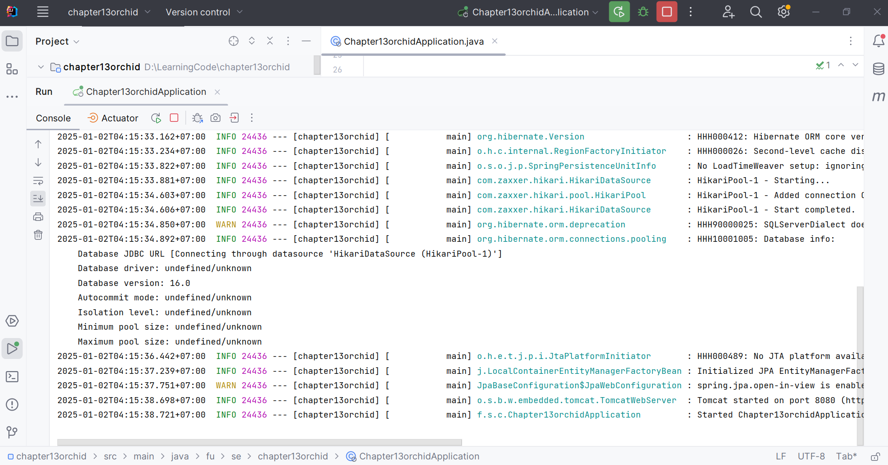

**Step 02.** Test the RESTful API using Postman

|  |  |  |  |  |
| --- | --- | --- | --- | --- |
|  | API name | HTTP Method | Path | Status Code |
| 1 | GET Orchids | GET | *http://localhost:8080/orchids/* | 200 OK |
| 2 | POST Orchid | POST | *http://localhost:8080/orchids/* | 201 Created |
| 3 | DELETE Orchid | DELETE | *http://localhost:8080/orchids/{id}* | 204 No Content |
| 4 | PUT Orchid | PUT | *http://localhost:8080/orchids/{id}* | 200 OK |
| 5 | GET Orchid | GET | *http://localhost:8080/orchids/{id}* | 20 OK |

**Step 02.** Test the GET method (for getting all orchids information)

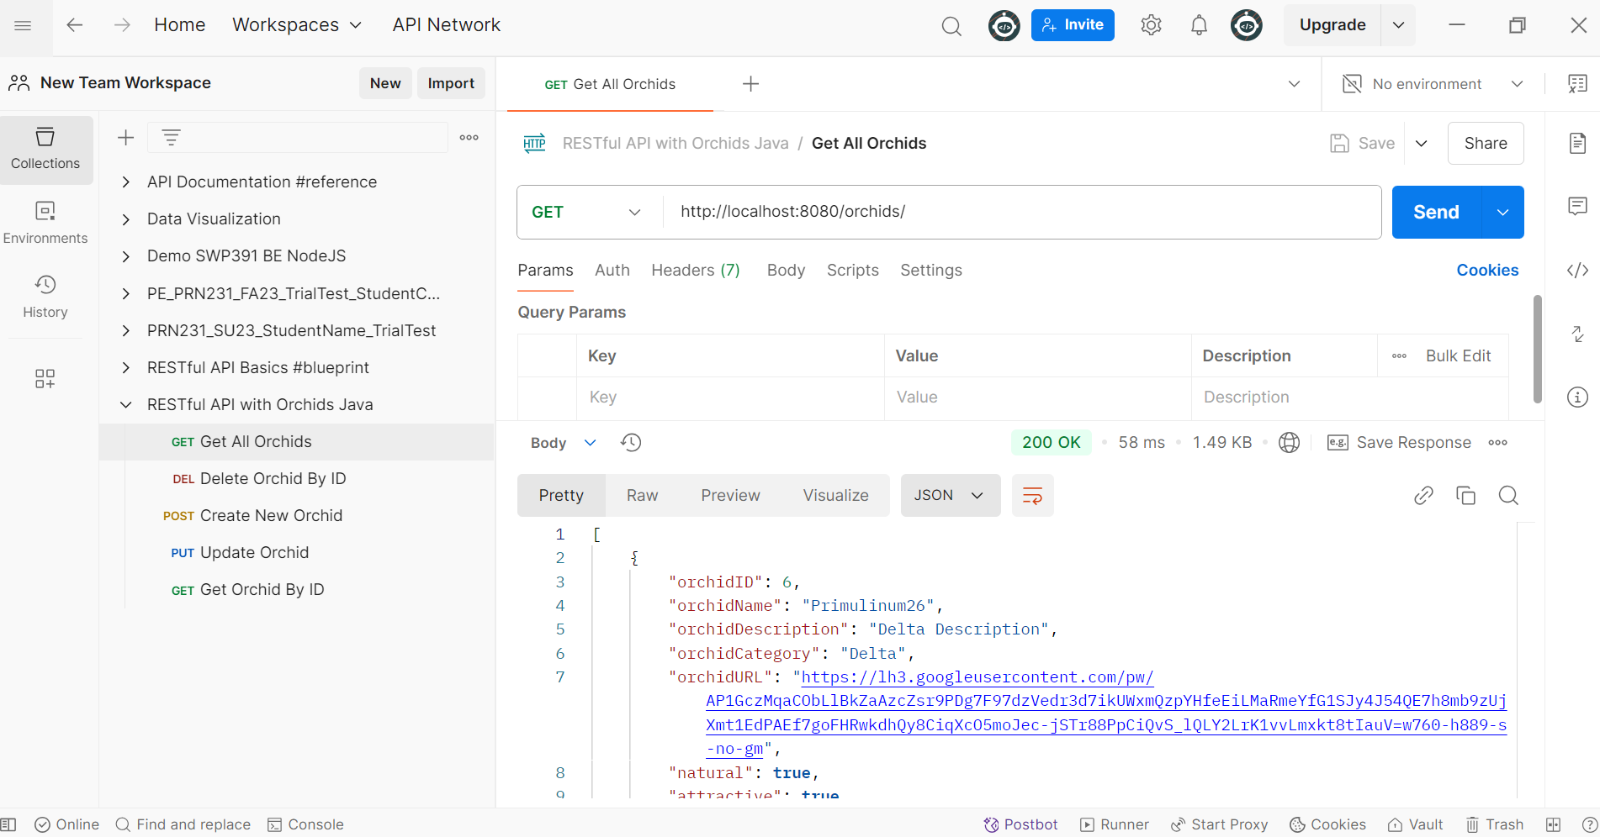

**Step 03.** Test the POST method for creating a new orchid

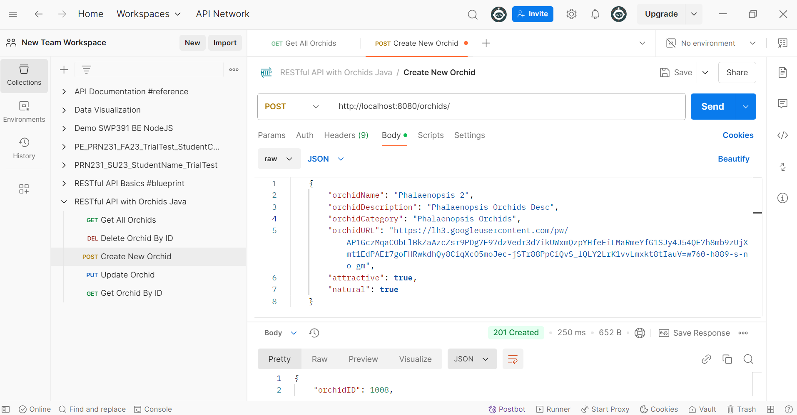

**Step 04.** Test the GET method for an existing orchid.

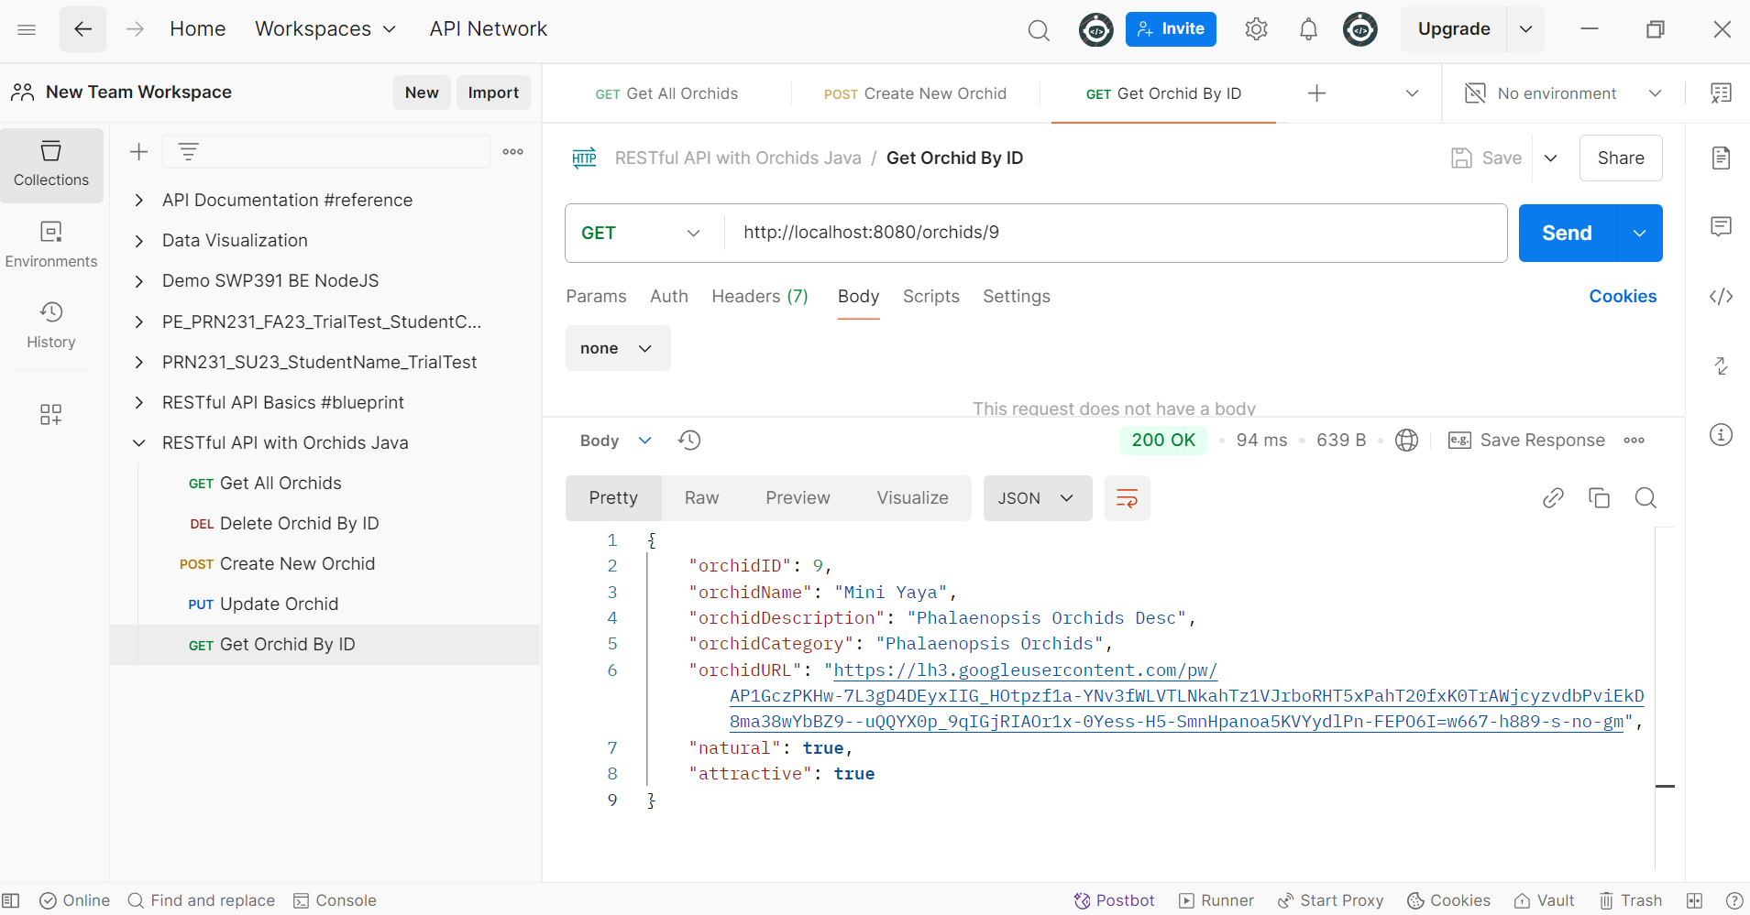

**Step 05.** Test the DELETE method for an existing orchid.

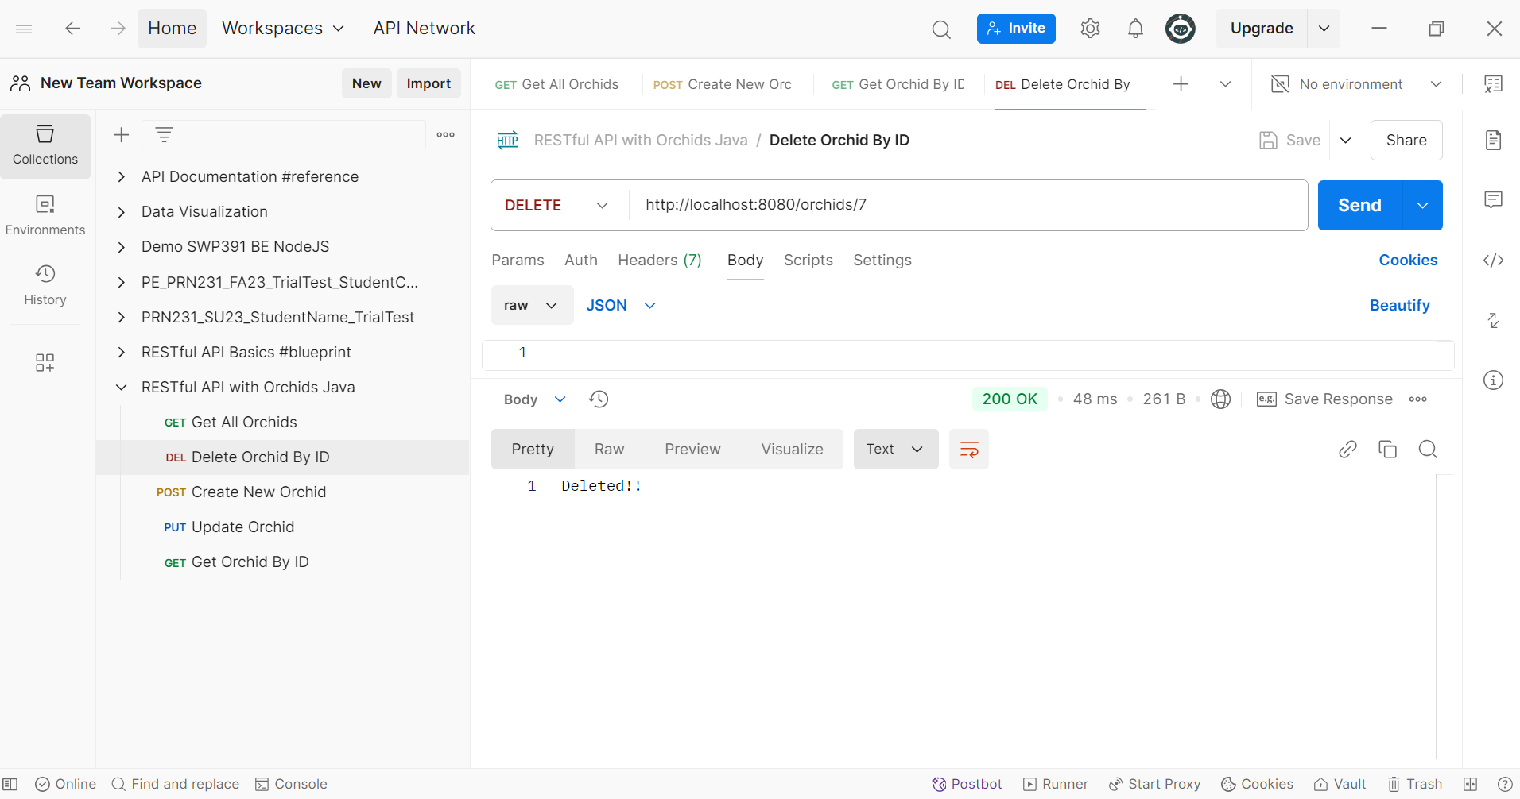

**Step 06.** Test the PUT method for an existing orchid.

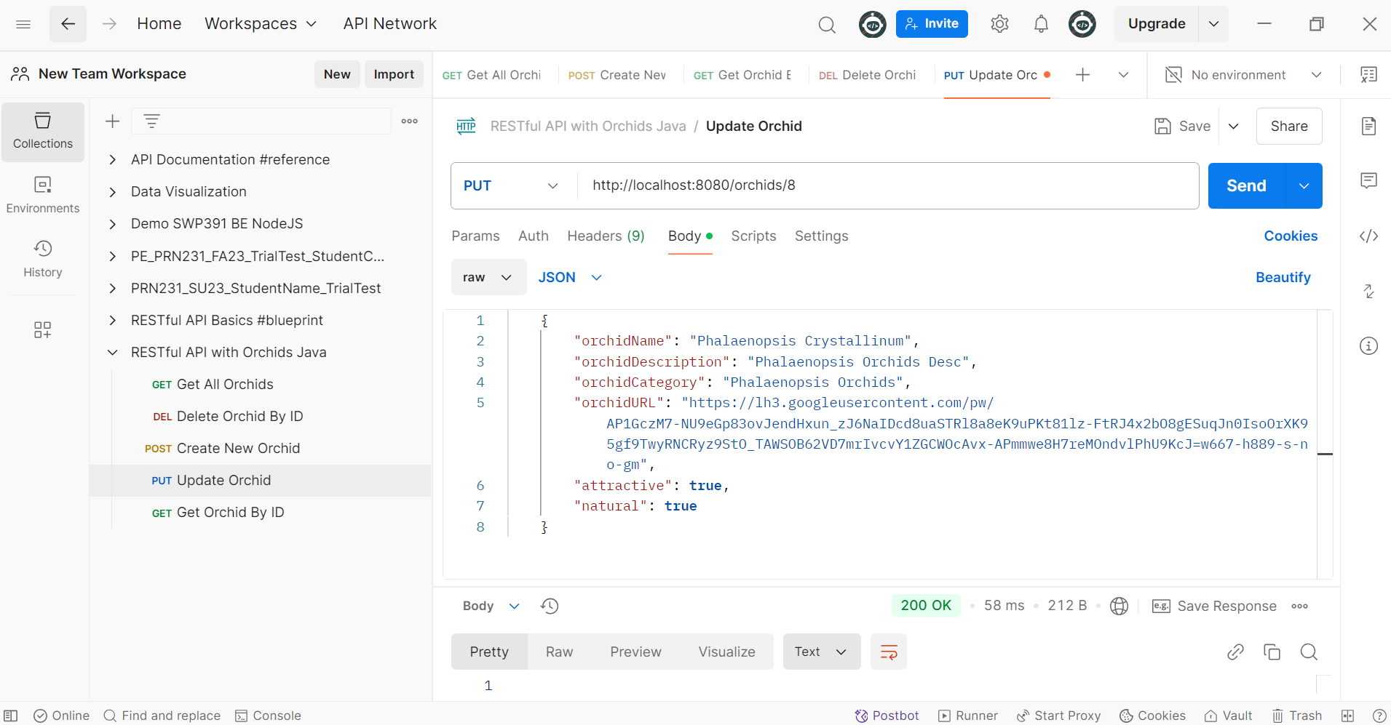

***Note 1. CrudRepository vs. JpaRepository interface***

@NoRepositoryBean

public interface **CrudRepository**<T,ID> extends Repository<T,ID>

<https://docs.spring.io/spring-data/commons/docs/current/api/org/springframework/data/repository/CrudRepository.html>

@NoRepositoryBean

public interface **JpaRepository**<T,ID> extends ListCrudRepository<T,ID>, **ListPagingAndSortingRepository**<T,ID>, QueryByExampleExecutor<T>

<https://docs.spring.io/spring-data/jpa/docs/current/api/org/springframework/data/jpa/repository/JpaRepository.html>

***Note 2. Quan hệ One-toOne, One-to-Many, Many-to-Many trong JPA (bidirection)***

Quan hệ One to Many (1 Department có nhiều Employee, 1 Employee chỉ thuộc về 1 Department)

@Entity  
public class Department {  
    @Id  
    @GeneratedValue(strategy = GenerationType.*IDENTITY*)  
    private Long id;  
    private String name;  
    @OneToMany(mappedBy = "department", cascade = CascadeType.*ALL*, orphanRemoval = true)  
    private List<Employee> employees = new ArrayList<>();  
    //Getters and Setters  
}

@Entity  
public class Employee {  
    @Id  
    @GeneratedValue(strategy = GenerationType.*IDENTITY*)  
    private Long id;  
    private String name;  
    @ManyToOne  
    @JoinColumn(name = "department_id")  
    private Department department;  
    //Constructors  
    //Getters, Setters  
}

Quan hệ One to One (1 Employee có 1 Address, 1 Address chỉ thuộc về 1 Employee)

@Entity  
public class Address {  
    @Id  
    @GeneratedValue(strategy = GenerationType.*IDENTITY*)  
    private Long id;  
  
    @OneToOne(fetch = FetchType.*LAZY*)  
    @JoinColumn(name = "person_id")  
    private Employee employee;  
  
    private String city;  
  
    //Constructors  
    //Getters, Setters  
}

@Entity  
public class Employee {  
    @Id  
    @GeneratedValue(strategy = GenerationType.*IDENTITY*)  
    private Long id;  
    private String name;

@ManyToOne  
    @JoinColumn(name = "department_id")  
    private Department department;

@OneToOne(mappedBy = "employee", cascade = CascadeType.*ALL*, fetch = FetchType.*LAZY*)  
    private Address address;

//Constructors  
    //Getters, Setters  
}

Quan hệ Many to Many (1 Student tham gia nhiều Course, 1 Course có nhiều Student tham gia)

@Entity  
public class Student {  
    @Id  
    @GeneratedValue(strategy = GenerationType.*IDENTITY*)  
    private Long id;  
  
    private String name;  
  
    @ManyToMany(mappedBy = "students")  
    private Set<Course> courses = new HashSet<>();

//Constructors  
    //Getters, Setters  
  
}

@Entity  
public class Course {  
    @Id  
    @GeneratedValue(strategy = GenerationType.*IDENTITY*)  
    private Long id;  
  
    private String name;  
  
    @ManyToMany  
    @JoinTable(  
            name = "course_student",  
            joinColumns = @JoinColumn(name = "course_id"),  
            inverseJoinColumns = @JoinColumn(name = "student_id")  
    )  
    private Set<Student> students = new HashSet<>();

    //Constructors  
    //Getters, Setters  
  
}